Mike Newton - 4105385

Bachelor of Information Technology

BIT695 TMA 4 Web Technologies Tutor Marked Assessment 4 - Application development for the internet

Task 1: Security and availability

1. The web application for Board Games Aficionados is a simple design with limited basic functions. It is designed to give the Members of the club as well as the club itself an online presence. It will provide advertising from only a web search and give the members an easy overview on what is happening.

When comparing the Web Page to the OWASP guide I do not believe it will pass. As described above it is a simple web application for a club. It is not an enterprise web application for company therefore does not need to be secure as per industry standards.

Password:

The original webpage has no Username and Password log on facility. This means there is nothing to protect the webpage from unwanted attention. The fact there is nothing of value contained within the webpage, except venue and game time information is beside the point

Basic Authentication and Session Management:

The fact this website has no means of authentication means that it is open to any visitor no matter who they are. Thus it is not protected from people who are not members and especially no protection against hackers. Now this site although simple, and may not have anything of value right away. The lack of a password requirement means visitors to the site can make changes over time. These could just be annoying sabotage or complete destruction.

Invalidated Redirects and Forwards:

The web application is such that it contains very few pages. These pages can easily be edited or modified as they are not protected against this form of attack. An attack can be as simple as adding text and a hyperlink to an external website. The text could just be a simple blurb advertising a new feature of the web application, such as “Pay Memberships online”. And inadvertently a member could click it, thinking this change had not been advertised to the club and provide the hacker with their credit card details as well as their name.

Sensitive Data exposure:

Currently there is no nothing in place to protect against this threat. For the moment the web application does not contain personal or sensitive information on a personal level. The site contains no credit cards, passwords or individuals data. However this may not always be the case, so when the web site is re designed to accommodate players records and carry transactions for club subscriptions this hole need to be fixed to make it a pass.

Within the context of this CIA triad, discuss the impact and importance of availability for an e-commerce enabled web application.

Availability is one of the 3 main goals which make up the CIA Triad. Availability is the goal with which the web application is able to be access by those who need it and when they need it. Availability is achieved when the web application is working as it should be. This has a number of requirements to make happen. The webserver needs to be maintained so it is always online, this is achieved by keeping the infrastructure up to date and services the requirements when needed, it’s Memory and Hard disks need to be looked after and increased as and when required. The hosting web server will need to have its operating system patches kept up to date to maintain security and lessening the attack surface for any would be hacker or malware.

Availability is a part of the CIA Triad this means it needs the other two goals, just as they need each other as well as availability also.

For an e commerce enabled web application, Availability is very important. Availability is the accessible presence of the web application. This means that it is available when the person wanting to use it needs it, there is a 24 hours a day 7 days a week expectation on web applications. For a lot of people the web application is how they continue throughout their day. For an everyday person, they do their shopping, they book a taxi and movie tickets. They organise dinner reservations, they are able to make bookings and plan a trip fully online through the web application. Of course for all these tasks there are other means to achieve the same result. However the loss of the e commerce side of the web application will mean that these tasks will require the user to do things different. They will have to make phone calls, they will have to meet with people face to face, and they will have to travel. Doing the same tasks without ecommerce it will be much more time consuming and frustrating. People get used to doing things a certain way and when this changes they notice the difference and all the negatives. This being said the loss of the ecommerce side of the web application will mean that they will have the business affected and would lose customers, effectively damaging their bottom line and this could cause major issue for the company, especially if the company has no other means of doing business then Availability is the oxygen supply.

C. a

What would you consider to be a limitation with this model in terms of today’s web applications?

The CIA Triad is a balance of Confidentiality, Integrity and Availability.

The need for good availability causes a limited use of security. The need of modern web applications is to be constantly accessible meaning high availability. Too much security which can include passwords, two factor authentication and security questions as well as access to different email accounts to recover passwords can lead to customer frustration in the event this information is not able to be found. We have all forgotten passwords. However to retrieve or reset a password these days there is a need to have access to the cell phone and email address used when the account was set up which is time consuming and not always easy.

Task 2: Version control

Step 1:

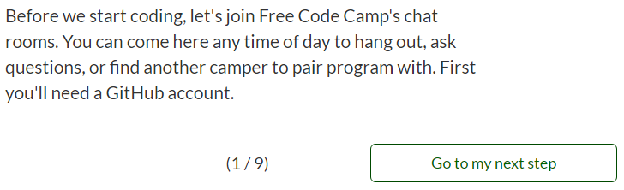

Creating Account

Create username and provide email address and password

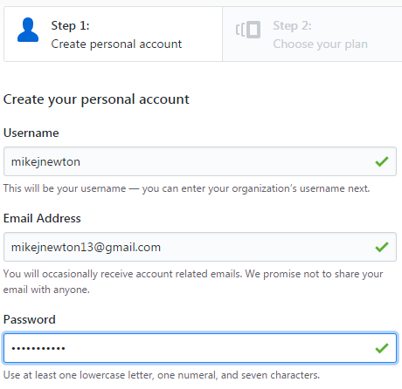



Choose which plan to use

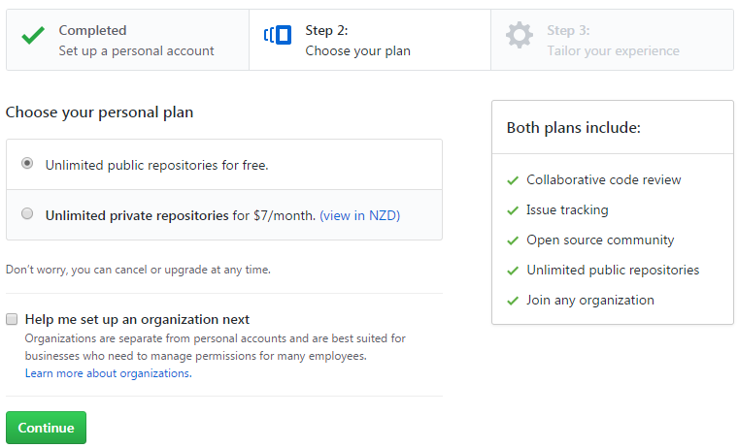

Select level of experience and what github will be used for and how best to describe yourself.

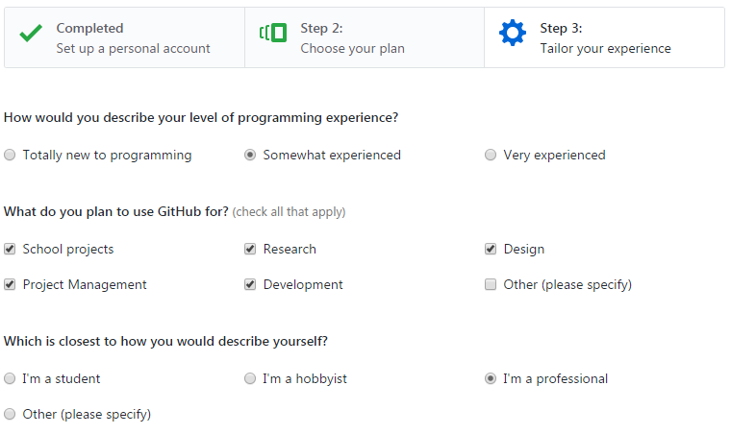



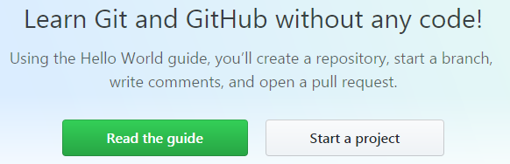

Forking an Existing Repository

Search for existing Repository

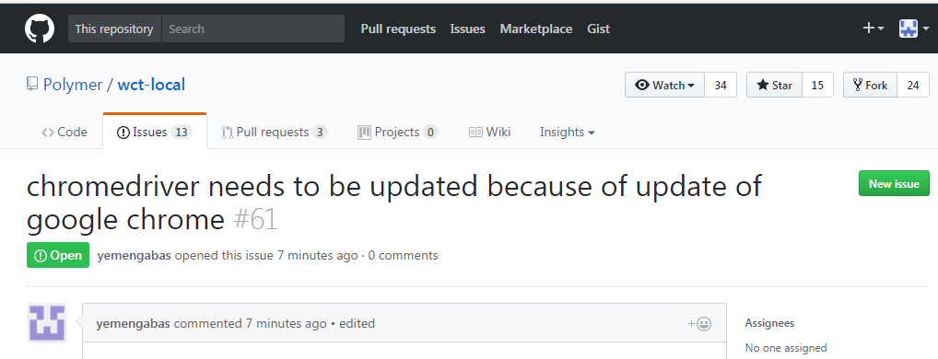

Click on the Fork button



Watch the process

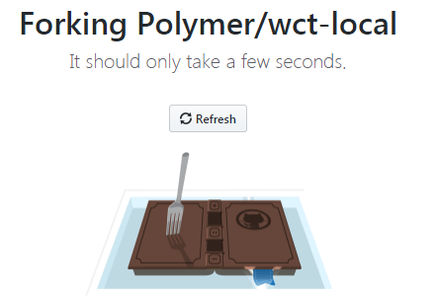

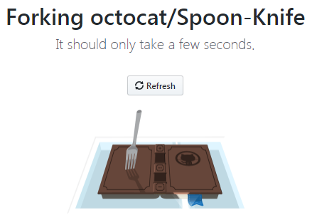

Viewing my profile

Under Popular repositories

* Wct-local
* Spoon-Knife

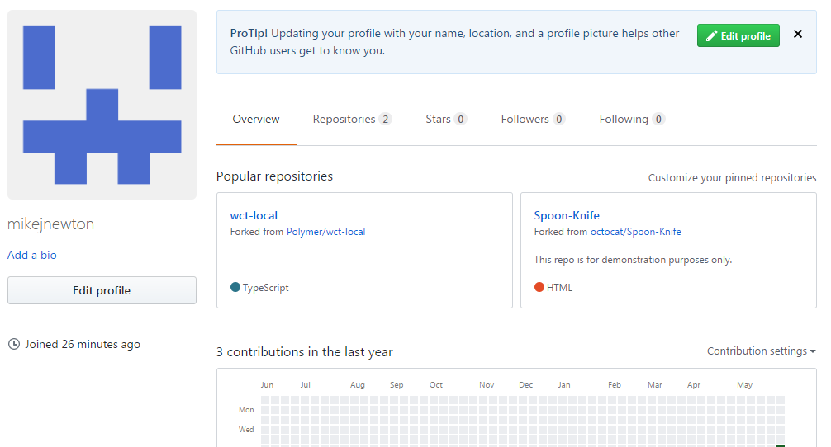

1. Once you have created your Github account, create a new repository that will be the home for your web application for Task 3.

Download and install the desktop or Command line (CLI) version of the Github client and connect it to your Github account.

Confirm the existence of your newly created repository. Use the desktop Github client to make a clone of the Freecodecamp repository.

Take screenshots of each of the steps you performed to prove you are able to use the tool in the above activities.

Create new Repository





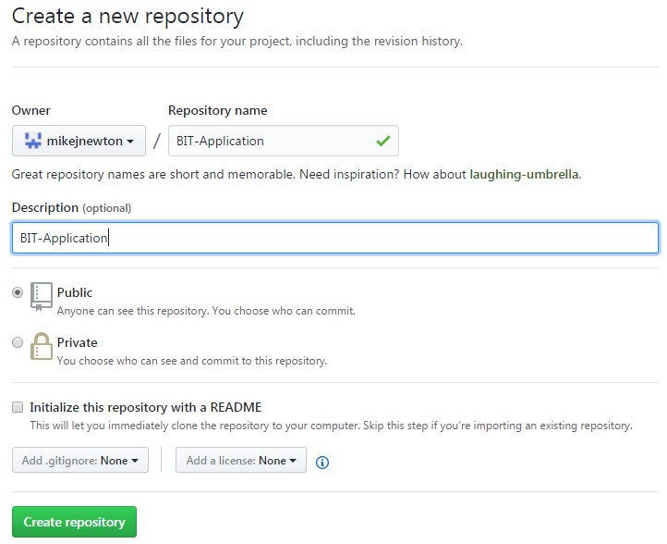

Set up in Desktop

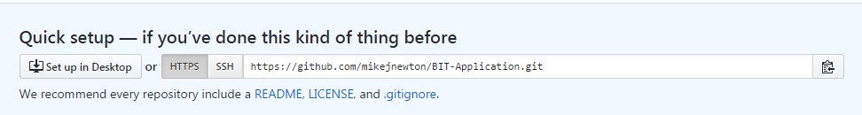

Download for Windows 64bit

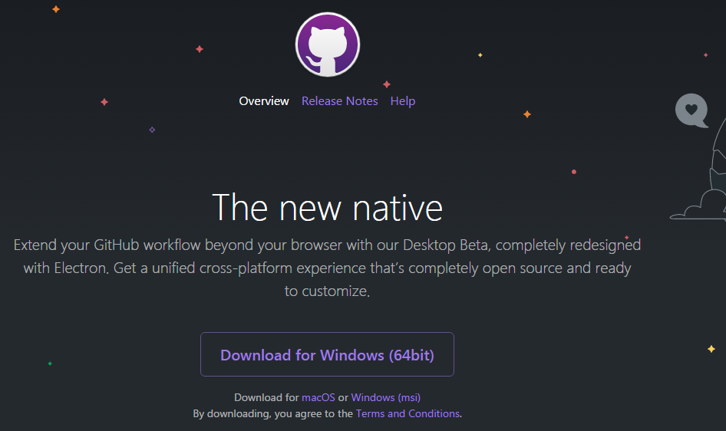

Download from Chrome



Security Warning – click Run

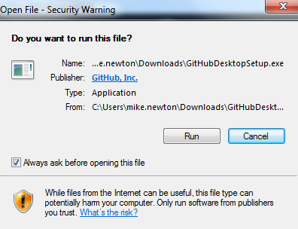

GitHub Desktop icon is now on desktop



Running GitHub Desktop

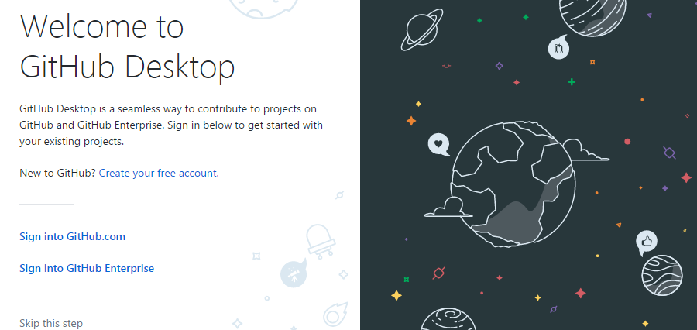

Sign in to my account



Enter username and password

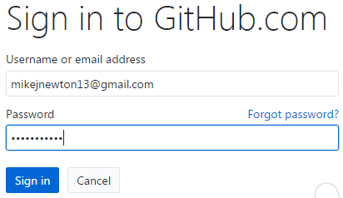

Option to Configure Git

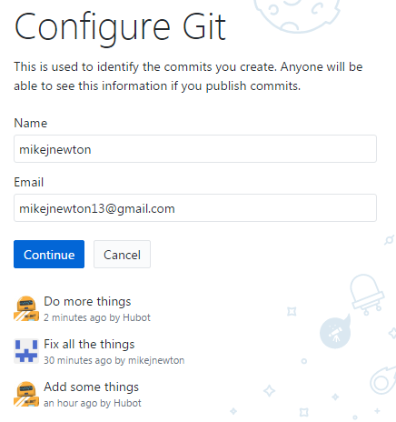

Continue clicked

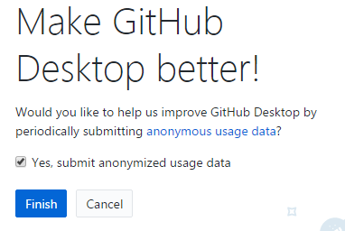

Click Finish

Clone an Existing Repository

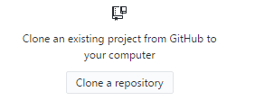

Find URL for freecodecamp: <https://github.com/freeCodeCamp/freeCodeCamp.git>

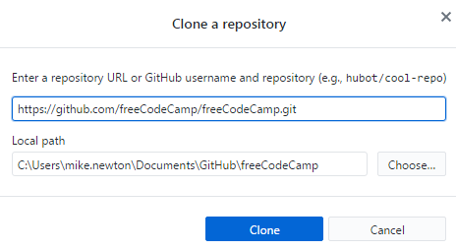

Click on Clone

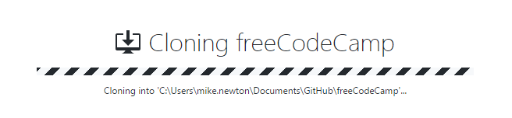

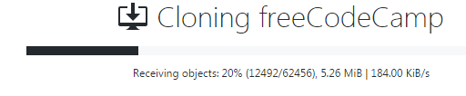

Freecodecamp now exists under the Current Repository

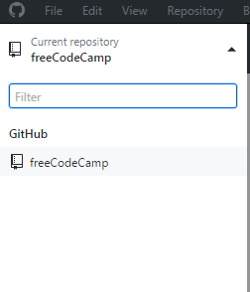

1. Browse to

<https://bitbucket.org/>

This is a platform very similar to Github. Take some time to peruse the site and compare this platform with Github. Describe the compared features.

Your answer should be in table form and you need to compare at least 10 features. Don’t just place a yes/no response into the table. Think of this table as a feasibility study for a project so the detail on the features matters.

Answer: Refer to Spreadsheet – Task 2 Version Control Question c

Task 3 Question A

1. Planning activity. All projects require planning if they are to succeed. For this question you need to create a schedule (tabular) of activities and a risk assessment. The schedule outlines how you are going to proceed with the development and when certain activities need to be completed by. The schedule should correlate with a typical application development lifecycle. Use the following table structure as an example for the schedule.

Using the Systems Development Life Cycle

Refer attached Spreadsheet: Task 3 Question a